***Motorcycle Loan Management System***

A motorcycle loan management system is a software solution designed to facilitate the entire lifecycle of motorbike loans, from application and approval to repayment and monitoring. It provides an automated and streamlined approach to managing motorbike financing, benefiting both lenders and borrowers.

The purpose of the motorbike loan management system is to streamline and automate the process of managing loans specifically for motorbikes. It aims to provide a convenient and efficient platform for both lenders and borrowers involved in motorbike financing.

The system serves multiple purposes, including:

* Loan Application Management: The system allows borrowers to submit loan applications online, providing a user-friendly interface to enter their personal and financial information, as well as necessary documentation. This streamlines the application process, eliminating the need for manual paperwork and reducing the time required for loan processing.
* Loan Approval and Verification: The system facilitates the verification of borrower information and documents, allowing lenders to assess the creditworthiness of applicants. It automates the verification process, enabling lenders to make informed decisions based on accurate and up-to-date information.
* Loan Repayment Tracking: The system provides tools to manage and track loan repayments. Borrowers can view their repayment schedule, make payments through various channels, and receive reminders for upcoming payments. Lenders can monitor the repayment status, generate payment reports, and handle any late payments or penalties.
* Loan Calculation and Amortization: The system incorporates loan calculation algorithms to determine loan amounts, interest rates, and repayment schedules based on predefined criteria. It helps borrowers understand the financial implications of their loans and enables lenders to generate accurate loan amortization schedules.
* Document Management: The system securely stores and manages borrower documents, such as identification proofs, income statements, and vehicle details. It provides a centralized repository for easy access and retrieval, ensuring compliance with regulatory requirements and reducing manual document handling.
* Reporting and Analytics: The system generates reports and provides analytics to lenders, offering insights into loan portfolios, delinquency rates, repayment trends, and other key performance indicators.

Also there are the Benefits On both side Lenders and Borrowers

Benefits for Lenders:

* Streamlined Loan Processing: The system automates and streamlines the loan application and approval process, reducing manual work and paperwork. This improves operational efficiency and allows lenders to process loan applications faster.
* Enhanced Risk Assessment: The system incorporates credit assessment tools and algorithms to evaluate borrower eligibility and creditworthiness. Lenders can make informed decisions based on accurate and up-to-date information, reducing the risk of loan defaults.
* Improved Loan Portfolio Management: The system provides comprehensive reporting and analytics capabilities, allowing lenders to monitor and manage their loan portfolios effectively. They can track performance metrics, identify potential risks, and make data-driven decisions for portfolio optimization.
* Better Customer Relationship Management: The system facilitates seamless communication with borrowers, providing updates on loan applications, repayment reminders, and notifications. This improves customer satisfaction and helps build strong relationships with borrowers.

Benefits for Borrowers:

* Convenient Application Process: Borrowers can easily apply for motorbike loans through an online platform, eliminating the need for physical paperwork and branch visits. The system provides a user-friendly interface for entering loan application information, making it more convenient for borrowers.
* Faster Loan Approval: With automated workflows and verification processes, the system expedites loan approval. Borrowers receive quicker responses on their loan applications, reducing waiting time and providing a faster access to funds.
* Accurate Loan Information: The system calculates loan amounts, interest rates, and repayment schedules accurately. Borrowers can review and understand the terms and conditions of their loans, ensuring transparency and informed decision-making.

The motorbike loan management system serves various target users involved in the loan process. The key user roles within the system include

Lenders:

* Loan officers and financial institutions responsible for providing motorbike loans.
* They evaluate loan applications, conduct credit assessments, and make loan approval decisions.
* Lenders monitor loan portfolios, track repayments, and manage overall loan operations.

Borrowers:

* Individuals or businesses seeking motorbike loans.
* Borrowers use the system to submit loan applications, provide required information and documentation, and track the status of their applications.
* They access loan repayment schedules, make payments, and receive notifications and reminders regarding their loan obligations.

Administrators:

* System administrators have overall control and management of the motorbike loan management system.
* They configure system settings, manage user roles and permissions, and oversee system maintenance and security.
* Administrators generate reports, perform system backups, and handle system updates and integrations.

Credit Officers:

* Credit officers are responsible for assessing the creditworthiness of borrowers.
* They review borrower information, perform credit checks, and provide recommendations or decisions regarding loan approvals.

Customer Support:

* Customer support representatives assist borrowers and lenders with any inquiries or issues related to the loan process.
* They provide support through various communication channels, including phone, email, or live chat.

The architecture of a Motorbike Loan Management System typically involves multiple components and layers working together to facilitate the loan management process. Here's a high-level overview of the typical architecture:

* User Interface Layer: This layer includes the user interface components that enable borrowers, loan officers, and administrators to interact with the system. It can be a web-based application or a mobile application that provides various functionalities like loan application, status tracking, and payment management.
* Application Layer: The application layer contains the core logic and business rules of the loan management system. It handles the processing and validation of loan applications, credit evaluation, loan approval, repayment calculations, and other loan-related operations. It coordinates the flow of data and interactions between the different components.
* Data Layer: The data layer manages the storage and retrieval of data used by the system. It typically includes a database or data storage system where all the loan-related information is stored, such as borrower details, loan agreements, repayment schedules, and transaction records. The data layer also handles data integrity, security, and backups.
* Integration Layer: The integration layer enables communication and integration with external systems and services. It may include APIs (Application Programming Interfaces) or integration modules to connect with credit bureaus, payment gateways, banking systems, and other third-party services. This layer facilitates data exchange and ensures seamless integration with external systems.
* Security Layer: The security layer focuses on securing the system and protecting sensitive data. It includes measures such as authentication, authorization, data encryption, and secure communication protocols. This layer ensures that only authorized users can access the system and that data remains confidential and protected.
* Reporting and Analytics Layer: This layer handles the generation of reports and analytics based on loan data. It may include reporting tools and data analytics components that collect, analyze, and present loan-related information in a meaningful way. These reports and analytics help in monitoring loan portfolios, identifying trends, and making informed decisions.
* Infrastructure Layer: The infrastructure layer comprises the hardware and software resources needed to host and run the system. It includes servers, networking
* **Requirements**
* **Functional Requirements**
* Loan Application: The system should provide a user-friendly interface for borrowers to submit loan applications online. It should collect all the necessary information required for evaluating the loan request, such as personal details, employment history, income, and desired loan amount.
* Credit Evaluation: The system should perform credit checks and assessments to determine the applicant's creditworthiness. It should integrate with credit bureaus or external systems to obtain credit reports and score calculations. The evaluation process should help in determining the loan eligibility and interest rates.
* Loan Approval and Documentation: The system should facilitate the loan approval process. It should generate loan agreements, promissory notes, and other necessary documents. Authorized personnel should be able to digitally sign and manage the loan approval process within the system.
* Disbursement: The system should handle the disbursement of funds after loan approval. It should manage the transfer of loan amounts to the borrower's account or directly to the motorbike dealer. The disbursement process should be integrated with payment gateways or banking systems.
* Loan Repayment: The system should provide functionality to manage loan repayments. It should generate repayment schedules, calculate interest, and allow borrowers to make periodic payments. It should handle various payment methods such as automated direct debit, online payments, or manual payments.

**Non-Functional Requirements**

* Performance: The system should be able to handle a large number of loan applications, approvals, and repayments efficiently, without significant delays or performance degradation. It should be designed to handle peak loads and ensure quick response times.
* Security: The system should ensure the security and confidentiality of sensitive borrower information. It should implement robust security measures such as encryption, access controls, and secure communication protocols to protect against unauthorized access, data breaches, and fraud.
* Scalability: The system should be designed to handle a growing number of users, loan applications, and data volume. It should be scalable to accommodate increased system usage without affecting performance or functionality.
* Reliability: The system should be highly reliable and available, ensuring minimal downtime or disruptions. It should have mechanisms in place to handle system failures, such as data backups, fault tolerance, and disaster recovery plans.
* Usability: The system should have a user-friendly interface that is intuitive and easy to navigate. It should provide clear instructions and guidance to borrowers, loan officers, and administrators. The system should be accessible to users with varying levels of technical expertise.
* Compliance: The system should adhere to relevant industry regulations and compliance standards, such as data protection and privacy laws. It should be designed to ensure compliance with applicable legal and regulatory requirements related to motorbike loans.

The view of the motorbike loan management system

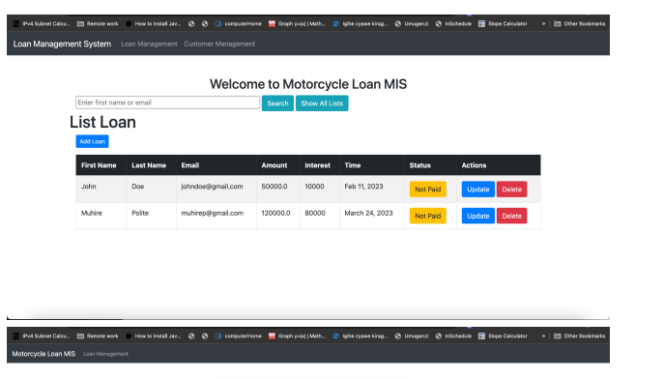

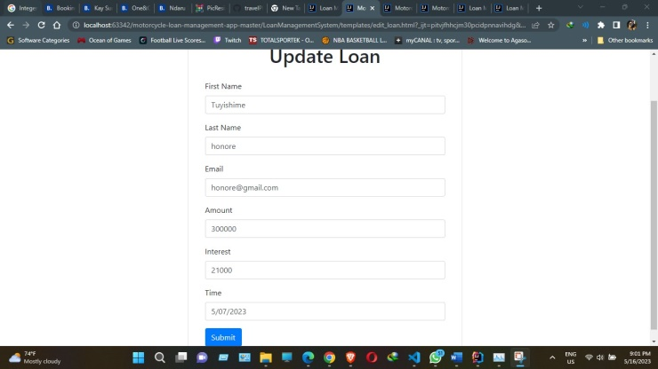

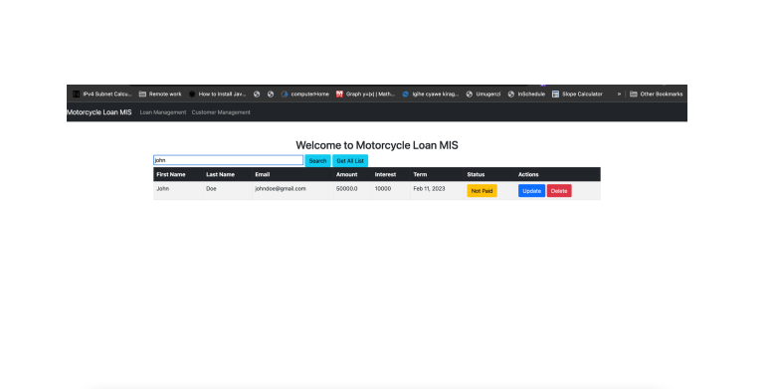

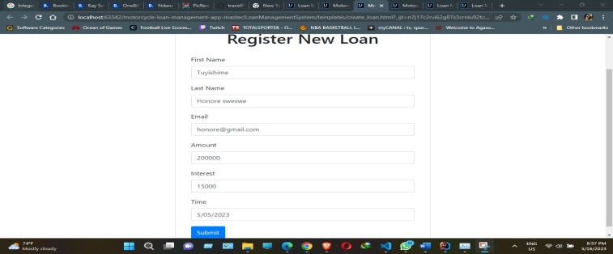

Motorcycle loan management system architecture

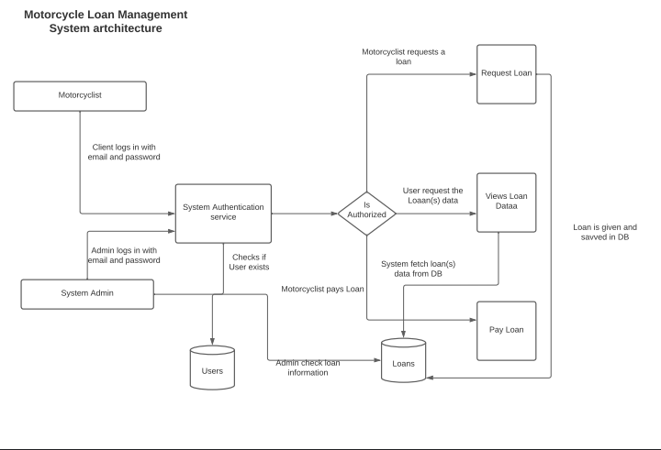

Motorcycle loan management system Database

